PYTHON ACTIVITY-BASED LEARNING
10 Selected Case Studies – Basic Python Programs
Prepared using the case studies listed in the supplied Python Activity-Based Learning PDF.
Note: Flowcharts are shown in a simple text-arrow format. Output is provided as text under test cases; screenshots are not included.

1. Attendance Recovery Computation
Problem statement: Calculate a student's current attendance percentage and find the minimum number of consecutive classes the student must attend to reach a required attendance percentage.

Objectives
- Calculate attendance percentage.
- Find the minimum future classes needed to reach the target.

Assumptions
- Classes attended and total classes are non-negative integers.
- The student attends every future class.
- The target attendance is 75%.

Algorithm
1. Start.
2. Read attended classes and total classes.
3. Calculate current attendance percentage.
4. If total classes is zero, display an error.
5. Otherwise, increase future classes one by one until attendance reaches 75%.
6. Display current percentage and required classes.
7. Stop.
Flowchart: Start → Input attended and total classes → Validate total classes → Calculate percentage → Check target using a loop → Display result → Stop

Pseudocode
BEGIN
INPUT attended, total
IF total <= 0 THEN print error
ELSE
percentage = attended / total * 100
future = 0
WHILE (attended + future) / (total + future) * 100 < 75
future = future + 1
END WHILE
PRINT percentage, future
END IF
END

Python source code

attended = int(input("Enter classes attended: "))
total = int(input("Enter total classes: "))

if attended < 0 or total <= 0 or attended > total:
print("Invalid input")
else:
percentage = (attended / total) * 100
print("Attendance percentage:", percentage, "%")

future = 0

while percentage < 75:
attended = attended + 1
total = total + 1
future = future + 1
percentage = (attended / total) * 100

print("Classes needed:", future)

Test cases and expected output
Test case 1: Input: 30, 40
Expected output: Current attendance: 75.0 % | Classes needed to reach 75%: 0
Test case 2: Input: 20, 40
Expected output: Current attendance: 50.0 % | Classes needed to reach 75%: 40

Conclusion
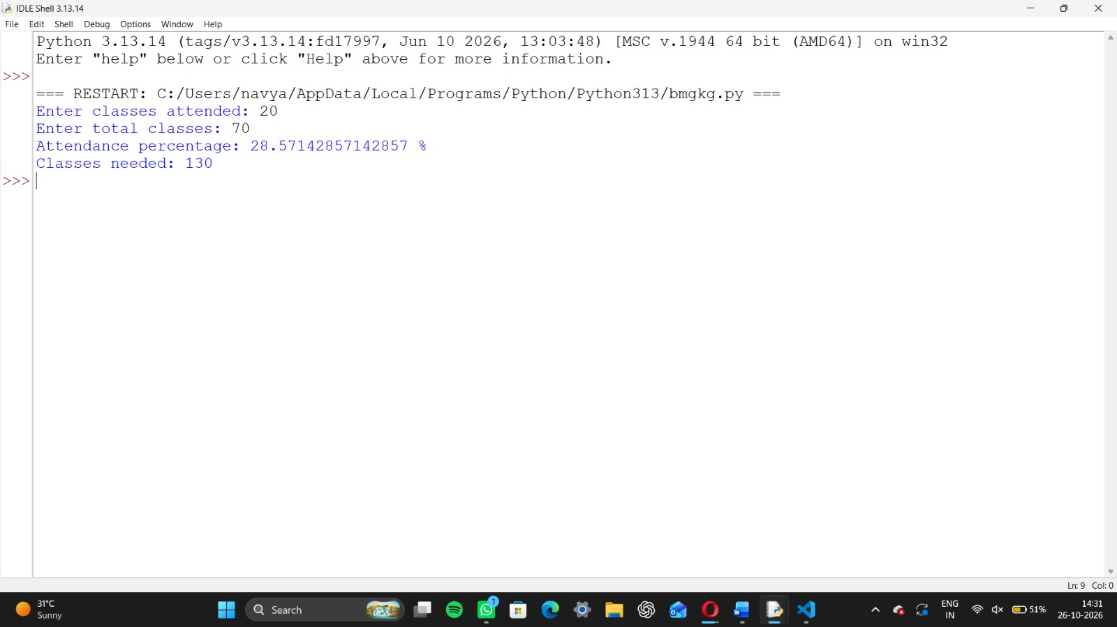

2. ATM Transaction Sequence Simulation
Problem statement: Process deposits and withdrawals, update an account balance, and reject withdrawals that are greater than the available balance.

Objectives
- Update balance after each transaction.
- Prevent withdrawals when funds are insufficient.

Assumptions
- Opening balance is ₹1000.
- Transaction type is D for deposit or W for withdrawal.
- Only positive transaction amounts are accepted.

Algorithm
1. Start with balance ₹1000.
2. Read number of transactions.
3. For each transaction, read type and amount.
4. Deposit positive amounts or withdraw if balance is enough.
5. Otherwise show an invalid transaction message.
6. Display final balance.
7. Stop.
Flowchart: Start → Set opening balance → Read transactions → Check type and amount → Update or reject transaction → Repeat → Show final balance → Stop

Pseudocode
BEGIN
balance = 1000
INPUT n
REPEAT n times
INPUT type, amount
IF amount <= 0 THEN print invalid
ELSE IF type = D THEN balance = balance + amount
ELSE IF type = W AND amount <= balance THEN balance = balance - amount
ELSE print rejected
PRINT balance
END

Python source code
balance = 1000
n = int(input("Number of transactions: "))
for i in range(n):
kind = input("Enter D for deposit or W for withdrawal: ").upper()
amount = float(input("Amount: "))
if amount <= 0:
print("Invalid amount")
elif kind == "D":
balance += amount
print("Deposit successful")
elif kind == "W" and amount <= balance:
balance -= amount
print("Withdrawal successful")
elif kind == "W":
print("Insufficient balance")
else:
print("Invalid transaction type")
print("Final balance: Rs.", round(balance, 2))

Test cases and expected output
Test case 1: Input: 2, D, 500, W, 200,
Expected output: Deposit successful | Withdrawal successful | Final balance: Rs. 1300.0
Test case 2: Input: 1, W, 1500,
Expected output: Insufficient balance | Final balance: Rs. 1000

Conclusion
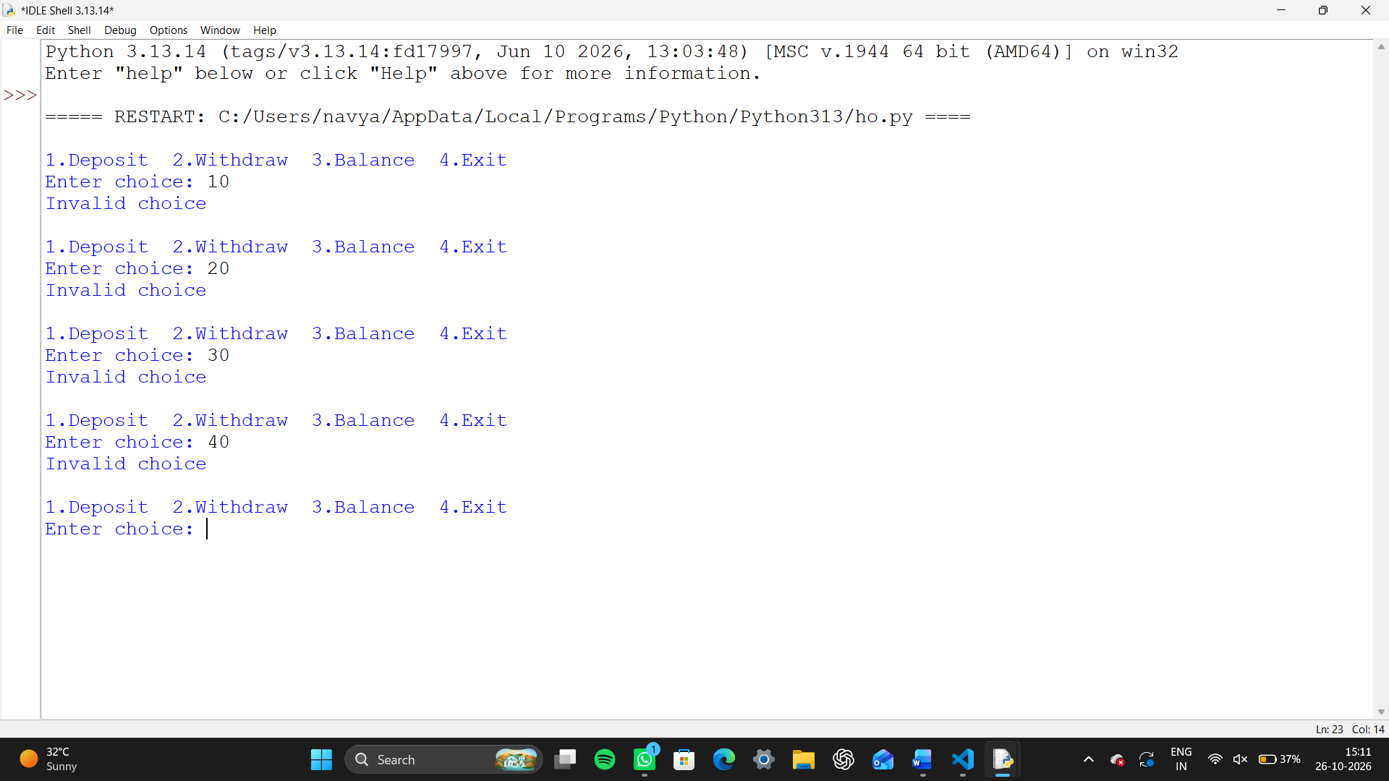

3. Warehouse Inventory Reconciliation
Problem statement: Compare opening stock, received stock, and dispatched stock for products to calculate the expected closing stock.

Objectives
- Calculate closing stock.
- Identify products with low or negative stock.

Assumptions
- All quantities are whole numbers.
- Expected closing stock = opening stock + received − dispatched.
- A closing stock below 5 is considered low.

Algorithm
1. Start.
2. Store product stock details in a list.
3. For each product, calculate closing stock.
4. Display closing stock.
5. If closing stock is below 5, display low-stock warning.
6. Stop.
Flowchart: Start → Read product stock list → Calculate closing stock for each product → Check low stock → Display results → Stop

Pseudocode
BEGIN
FOR each product in stock list
closing = opening + received - dispatched
PRINT product, closing
IF closing < 5 THEN PRINT low stock
END FOR
END

Python source code
stock = [
("Pen", 20, 10, 18),
("Book", 15, 5, 8),
("Pencil", 12, 2, 11)
]
for product, opening, received, dispatched in stock:
closing = opening + received - dispatched
print(product, "closing stock:", closing)
if closing < 5:
print("Low stock warning")

Test cases and expected output
Test case 1: Input: Predefined sample data
Expected output: Pen closing stock: 12 | Book closing stock: 12 | Pencil closing stock: 3 | Low stock warning

Conclusion
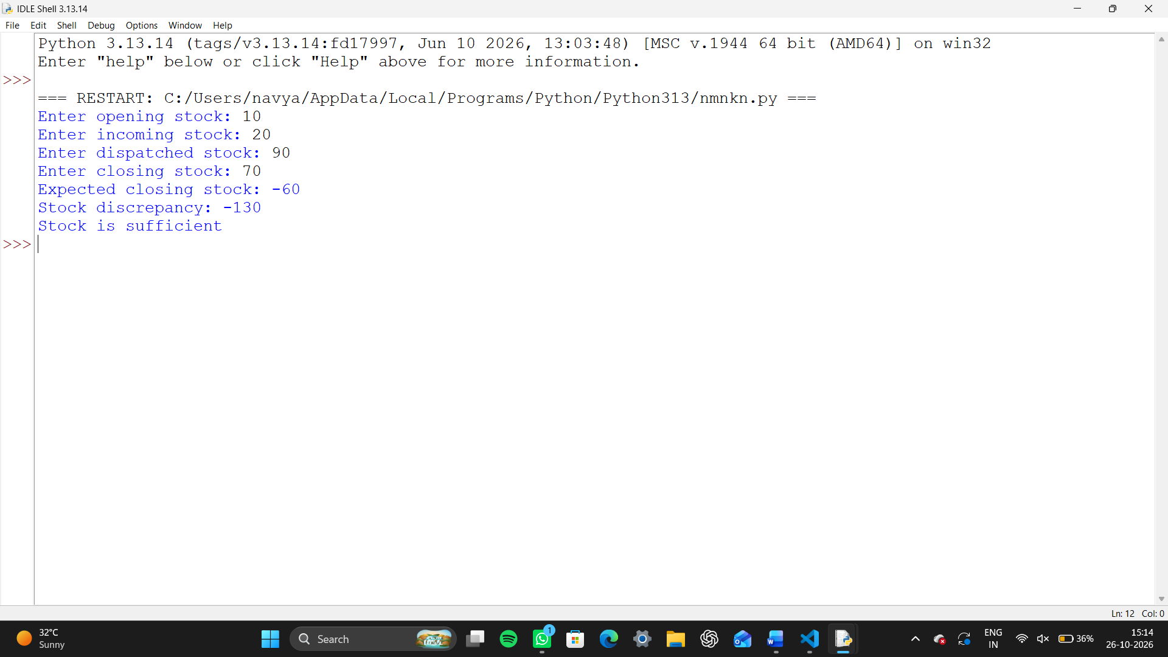

4. Student Performance Trend Analysis
Problem statement: Compare a student's marks in two tests for different subjects and identify whether marks improved or decreased.

Objectives
- Compare marks across two tests.
- Display improvement or decline for each subject.

Assumptions
- Marks are out of 100.
- The same subjects are used in both tests.
- A difference of zero means no change.

Algorithm
1. Start.
2. Store subject names and two test marks.
3. For each subject, calculate second-test marks minus first-test marks.
4. Display improved, decreased, or unchanged.
5. Stop.
Flowchart: Start → Store subject marks → Calculate difference → Check positive/negative/zero → Display trend → Stop

Pseudocode
BEGIN
FOR each subject
change = test2 - test1
IF change > 0 print Improved
ELSE IF change < 0 print Decreased
ELSE print No change
END FOR
END

Python source code
math1 = int(input("Enter first exam marks: "))
math2 = int(input("Enter second exam marks: "))

science1 = int(input("Enter first science marks: "))
science2 = int(input("Enter second science marks: "))

print("Math improvement:", math2 - math1)
print("Science improvement:", science2 - science1)

if math2 < 35:
print("Math: Weak subject")

if science2 < 35:
print("Science: Weak subject")

average = (math2 + science2) / 2

if average >= 75:
print("Student Grade: A")
elif average >= 50:
print("Student Grade: B")
else:
print("Student Grade: C")Test cases and expected output
Test case 1: Input: Predefined sample data
Expected output: Python improved by 12 marks | Maths decreased by 7 marks | English no change

Conclusion
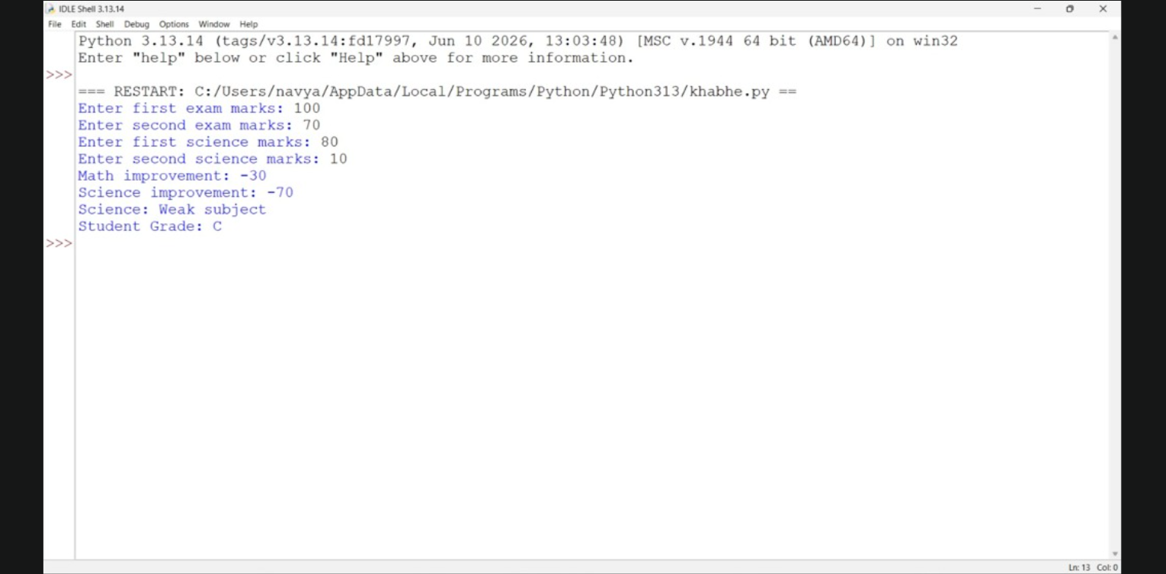

5. Fuel Consumption and Route Comparison
Problem statement: Calculate fuel required and travel cost for different vehicles, then identify the vehicle with the lowest journey cost.

Objectives
- Calculate fuel required using distance and mileage.
- Compare journey costs.

Assumptions
- Journey distance is 200 km.
- Fuel price is ₹105 per litre.
- Mileage values are greater than zero.

Algorithm
1. Start.
2. Set journey distance and fuel price.
3. Store vehicles and their mileage.
4. For each vehicle, calculate fuel needed and cost.
5. Display each cost.
6. Find and display the lowest-cost vehicle.
7. Stop.
Flowchart: Start → Set distance and fuel price → Read vehicle mileage list → Calculate fuel and cost → Compare costs → Display cheapest vehicle → Stop

Pseudocode
BEGIN
distance = 200; price = 105
FOR each vehicle
fuel = distance / mileage
cost = fuel * price
FIND minimum cost
PRINT all costs and cheapest vehicle
END

Python source code
distance = float(input("Enter journey distance in km: "))
fuel_price = float(input("Enter fuel price per litre: "))

Vehicle mileage in km per litre
vehicle1_mileage = float(input("Enter Vehicle 1 mileage: "))
vehicle2_mileage = float(input("Enter Vehicle 2 mileage: "))

Extra fuel kept as a reserve
reserve = float(input("Enter reserve fuel in litres: "))
fuel1 = distance / vehicle1_mileage + reserve
fuel2 = distance / vehicle2_mileage + reserve
cost1 = fuel1 * fuel_price
cost2 = fuel2 * fuel_price
print("Vehicle 1 journey cost:", cost1)
print("Vehicle 2 journey cost:", cost2)
if cost1 < cost2:
print("Vehicle 1 is cheaper.")
else:
print("Vehicle 2 is cheaper.")

Test cases and expected output
Test case 1: Input: Predefined sample data
Expected output: Bike travel cost: Rs. 525.0 | Car travel cost: Rs. 1400.0 | Scooter travel cost: Rs. 466.67 | Lowest-cost vehicle: Scooter

Conclusion
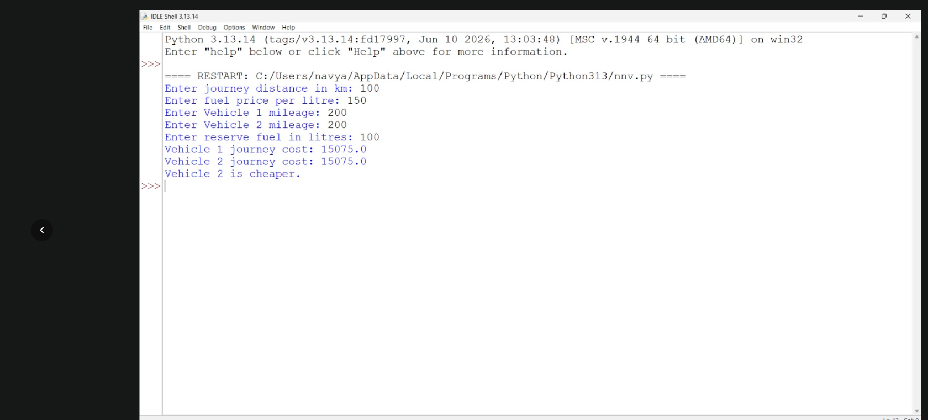

6. Repeated Transaction Detection
Problem statement: Check a list of transaction IDs and identify any IDs that appear more than once.

Objectives
- Find duplicate transaction IDs.
- Display each repeated ID only once.

Assumptions
- Transaction IDs are strings.
- The list is already available in the program.
- A repeated ID is treated as a possible duplicate.

Algorithm
1. Start.
2. Store transaction IDs in a list.
3. Check each ID against the seen list.
4. If already seen and not reported, add it to duplicates.
5. Otherwise add it to seen.
6. Display duplicates.
7. Stop.
Flowchart: Start → Read transaction IDs → Check each ID → Seen before? → Add to duplicate list or seen list → Display duplicates → Stop

Pseudocode
BEGIN
seen = []; duplicates = []
FOR each id in transactions
IF id in seen AND id not in duplicates THEN add id to duplicates
ELSE add id to seen
PRINT duplicates
END

Python source code
transactions = [
("T101", 100),
("T102", 500),
("T101", 100),
("T103", 2000)
]

for transaction in transactions:
transaction_id = transaction[0]
amount = transaction[1]

if amount > 1000:
print(transaction_id, "has a large amount")

for other in transactions:
if transaction != other and transaction_id == other[0]:
print(transaction_id, "is repeated")
break

Test cases and expected output
Test case 1: Input: Predefined sample data
Expected output: Repeated transaction IDs: ['T102', 'T101']

Conclusion
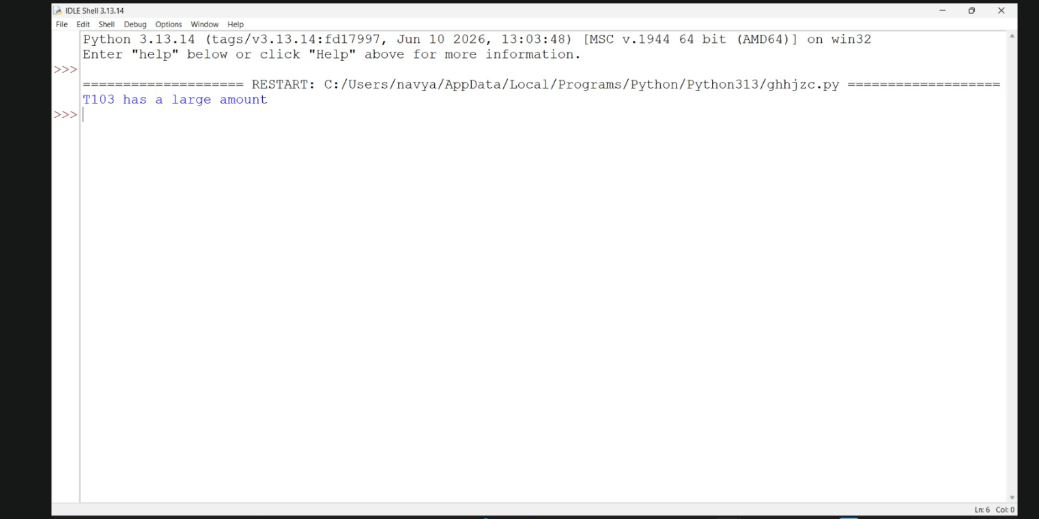

7. Password Policy Validation
Problem statement: Check whether a sample password has at least eight characters and contains both a letter and a digit.

Objectives
- Validate a password using simple string operations.
- Display whether it meets the given rules.

Assumptions
- Password length must be at least 8.
- Password must contain at least one letter and one digit.
- This is a classroom demonstration, not a complete security checker.

Algorithm
1. Start.
2. Read password.
3. Check its length.
4. Check whether it has a letter and a digit.
5. Display valid if all conditions are met; otherwise display invalid.
6. Stop.
Flowchart: Start → Input password → Check length → Check letter and digit → All conditions met? → Display result → Stop

Pseudocode
BEGIN
INPUT password
has_letter = any character is a letter
has_digit = any character is a digit
IF length >= 8 AND has_letter AND has_digit THEN print valid
ELSE print invalid
END

Python source code

password = input("Enter a password: ")

if len(password) < 8:

print("Failed: use at least 8 characters.")

if not any(letter.isupper() for letter in password):

print("Failed: add an uppercase letter.")

if not any(letter.islower() for letter in password):

print("Failed: add a lowercase letter.")

if not any(letter.isdigit() for letter in password):

print("Failed: add a number.")

if "password" in password.lower():

print("Failed: do not include the word 'password'.")

if "aaa" in password.lower():

print("Failed: do not repeat 'a' three times.")

if (

len(password) >= 8

and any(letter.isupper() for letter in password)

and any(letter.islower() for letter in password)

and any(letter.isdigit() for letter in password)

and "password" not in password.lower()

and "aaa" not in password.lower()

):

print("Password is valid.") Test cases and expected output
Test case 1: Input: Python123
Expected output: Password meets the given rules
Test case 2: Input: hello
Expected output: Password does not meet the given rules

Conclusion
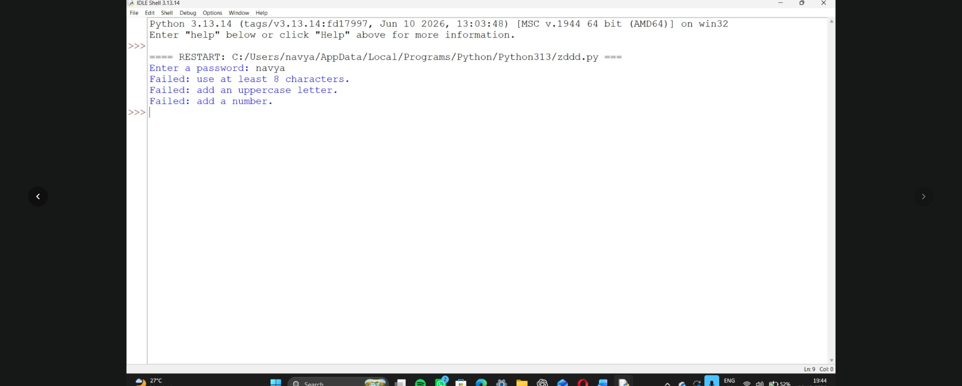

8. String-Based Examination Answer Evaluation
Problem statement: Compare a student's answers with an answer key and count correct, incorrect, and unanswered responses.

Objectives
- Compare answer strings.
- Calculate the number of correct, incorrect, and unanswered answers.

Assumptions
- Each answer is one letter.
- A blank answer is unanswered.
- No negative marking is applied.

Algorithm
1. Start.
2. Store the answer key and student answers.
3. Set all counters to zero.
4. Compare each answer with the key.
5. Update correct, incorrect, or unanswered counter.
6. Display all counts.
7. Stop.
Flowchart: Start → Store key and student answers → Compare each answer → Update counters → Display result → Stop

Pseudocode
BEGIN
key = [A, B, C, D, A]
answers = [A, C, blank, D, A]
set counters to zero
FOR each answer position
IF blank increase unanswered
ELSE IF equal to key increase correct
ELSE increase incorrect
PRINT counters
END

Python source code

answer_key = ["A", "C", "B", "D"]

students = [

["A", "C", "D", "D"],

["A", "", "B", "C"]

]

for number in range(len(students)):

correct = 0

incorrect = 0

unanswered = 0

for i in range(len(answer_key)):

answer = students[number][i]

if answer == "":

unanswered = unanswered + 1

elif answer == answer_key[i]:

correct = correct + 1

else:

incorrect = incorrect + 1

score = correct - (incorrect * 0.25)

print("Student", number + 1)

print("Correct:", correct)

print("Incorrect:", incorrect)

print("Unanswered:", unanswered)

print("Score:", score) Test cases and expected output

Test cases and expected output
Test case 1: Input: Predefined sample data
Expected output: Correct answers: 3 | Incorrect answers: 1 | Unanswered: 1

Conclusion
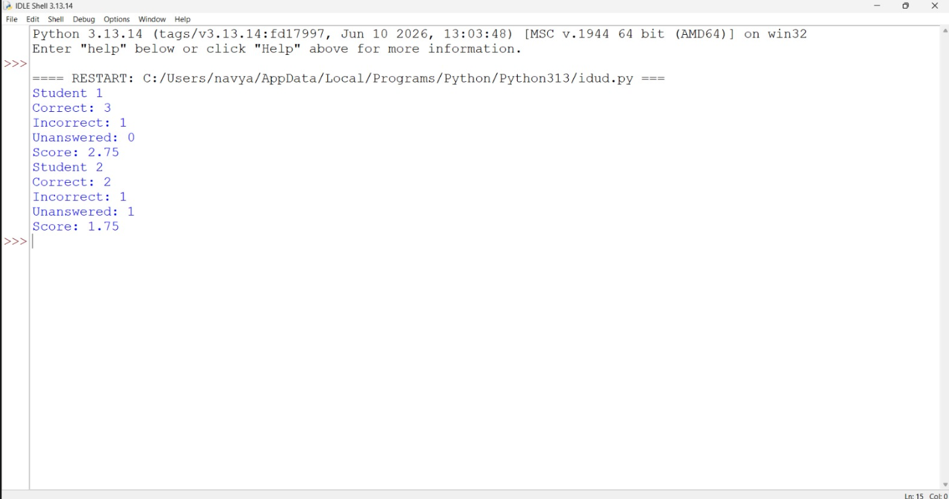

9. Student Marks Matrix Analysis
Problem statement: Use a nested list to store marks of students in different subjects and calculate each student's total and average marks.

Objectives
- Use a nested list to store marks.
- Calculate total and average marks for each student.

Assumptions
- Each student has marks in three subjects.
- Marks are between 0 and 100.
- The example contains three students.

Algorithm
1. Start.
2. Store student names and marks in a nested list.
3. For each student, calculate total marks.
4. Calculate average by dividing total by number of subjects.
5. Display total and average.
6. Stop.
Flowchart: Start → Store student marks in nested list → Calculate total and average → Display each student's result → Stop

Pseudocode
BEGIN
FOR each student and marks row
total = sum(marks)
average = total / number of subjects
PRINT student, total, average
END FOR
END

Python source code
marks = [
[80, 75, 90],
[60, 55, 70],
[95, 85, 92]
]

# Calculate each student's total and average
for i in range(len(marks)):
total = sum(marks[i])
average = total / len(marks[i])

print("Student", i + 1, "total:", total)
print("Student", i + 1, "average:", average)

# Calculate each subject's average
for subject in range(3):
total = 0

for student in range(len(marks)):
total = total + marks[student][subject]

average = total / len(marks)

print("Subject", subject + 1, "average:", average)

if average < 60:
print("This subject has a low average.")

Test cases and expected output
Test case 1: Input: Predefined sample data
Expected output: Asha total: 245 average: 81.67 | Ravi total: 203 average: 67.67 | Sara total: 275 average: 91.67

Conclusion
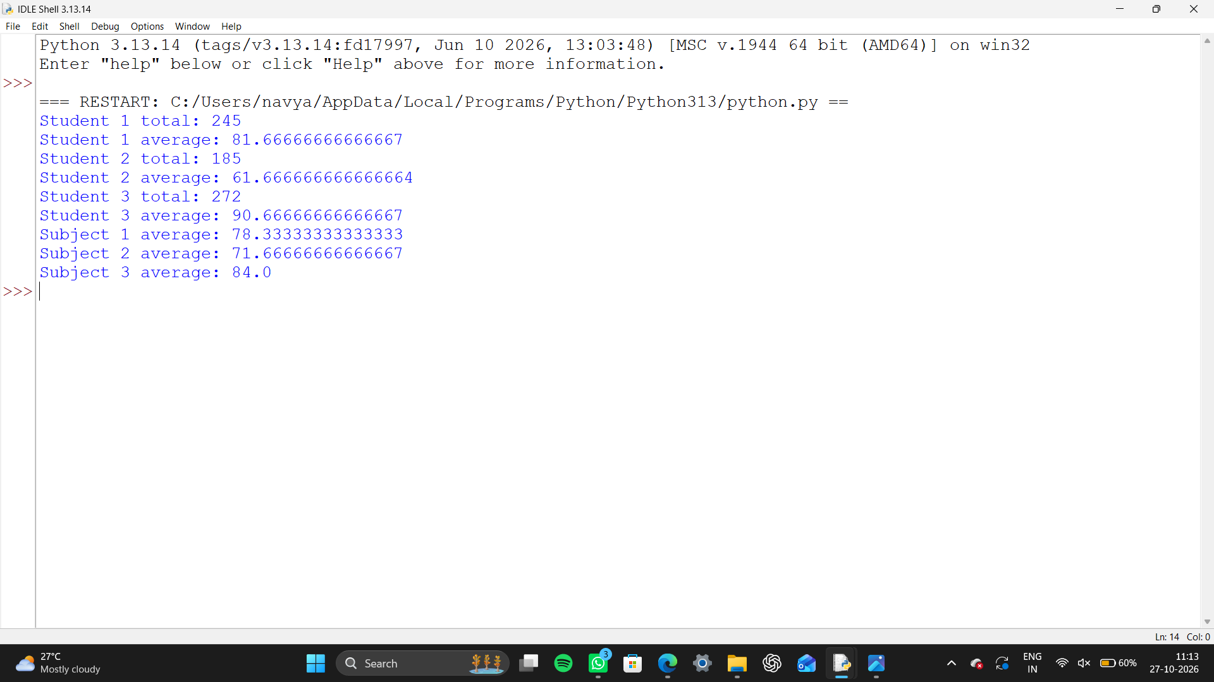

10. Tuple-Based Product Catalogue Audit
Problem statement: Store product details in tuples and calculate the total value of available stock. Identify products that need replenishment.

Objectives
- Use tuples to store product information.
- Calculate stock value and identify low-stock products.

Assumptions
- Each tuple contains product name, price, and quantity.
- Stock value = price × quantity.
- A quantity below 5 needs replenishment.

Algorithm
1. Start.
2. Store product details as tuples.
3. For each tuple, unpack name, price, and quantity.
4. Calculate stock value.
5. Display stock value.
6. If quantity is below 5, show replenishment warning.
7. Stop.
Flowchart: Start → Store product tuples → Unpack product details → Calculate stock value → Check quantity → Display report → Stop

Pseudocode
BEGIN
FOR each (name, price, quantity) in products
value = price * quantity
PRINT name, value
IF quantity < 5 THEN PRINT replenish
END FOR
END

Python source code

Each tuple contains: product ID, price, stock quantity
products = ( ("P01", 10, 5), ("P02", 20, 2), ("P03", -5, 4) )
for product in products: product_id = product[0] price = product[1] stock = product[2]
print("Product:", product_id)
if price <= 0 or stock < 0:
print("Invalid product record.")
else:
value = price * stock
print("Inventory value:", value)
if stock < 3:
print("Needs replenishment.")
Test case 1: Input: Predefined sample data
Expected output: Notebook stock value: Rs. 500 | Pen stock value: Rs. 30 | Replenishment needed | Bag stock value: Rs. 1200 | Replenishment needed

Conclusion
